Chapter 6 Volcano Eruptions
- ___________________-- is a vent or fissure in the Earth’s surface through which molten rock and gases are expelled.
- Molten rock is called ____________________.
- Magma that flows onto the Earth’s surface is called _____________.
Nonexplosive Eruptions
- ______________________________________ are the most common type of volcanic eruptions. These eruptions produce relatively __________ flows of lava in huge amounts.
- Vast areas of the Earth’s surface, including much of the sea floor and the Northwestern United States, are covered with lava from _______________________ eruptions.
- While ________________________eruptions are much rarer than non-explosive eruptions, the effects can be incredibly destructive.
- During an explosive eruption, _____________________________, ____________, and ______________ rapidly shoot out from a volcano.
- An explosive eruption can also blast millions of tons of ______________________ from a volcano, and can demolish and entire mountainside.
What is inside a volcano?
- The interior of a volcano is made up of ____________ main features.
- The _______________________ is the body of molten rock deep underground that feeds a volcano.
- The _____________ is an opening at the surface of the Earth through which volcanic material passes.
What Makes Up Magma?
- By comparing magma from different eruptions, scientists have learned that the composition of the magma affects _________________________________________________________.
- The key to whether an eruption will be explosive lies in the ____________, ___________, and ___________ content of the magma.
- _____________________________ are an Explosive Combination If the water content of magma is high, an explosive eruption is more likely.
- While ________________________, magma is under intense pressure and water in it stays dissolved. If the magma quickly moves to the surface, pressure suddenly decreases and the water and other compounds become _____________.
- As gases expand rapidly, an ___________________can result.
- ____________________________________________________________________________ and with a high silica content, also tends to cause explosive eruptions.
- Silica-rich magma has a _________________ consistency, so it flows slowly and tends to harden in a volcano’s vents. As a result, it _________________________________________.
- As more magma pushes up from below, _______________________ increases. If enough pressure builds up, an explosive eruption takes place.
What Erupts from a Volcano?
- Magma erupts as either __________ or _____________________________ material.
- _____________ is liquid magma that flows from a volcanic vent.
- ___________________________________ forms when magma is blasted into the air and hardens.
Types of Lava
- The viscosity of lava, or ___________________________, varies greatly. Lava that has high viscosity is ___________________. Lava that has low viscosity is more __________________.
- The viscosity of lava affects the surface of a lava flow in different ways. Four types of lava are shown on the next slide.
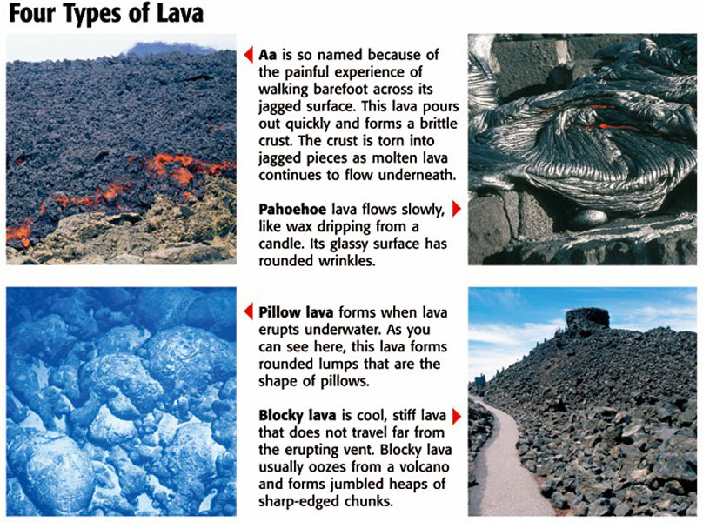
Types of Pyroclastic Material
- When magma explodes from a volcano and solidifies in the air, __________________________ material is formed.
- Pyroclastic material also forms when powerful eruptions ___________________ existing rock.
There are four types of pyroclastic material:
1. __________________________________ are large blobs of magma that harden in the air.
2. ______________________________ are pieces of solid rock erupted from a volcano. Volcanic blocks are the largest pieces of pyroclastic material.
3. __________________are small, pebblelike bits of magma that hardened before they hit the
ground.
4. ____________________________ forms when the gases in stiff magma expand rapidly and the walls of the gas bubbles explode into tiny, glasslike slivers. Ash makes up most of the pyroclastic material in an eruption.
What Erupts from a Volcano?, continued
- _______________________________________ are dangerous volcanic flows that are produced when enormous amounts of hot ash, dust, and gases are ejected from a volcano.
- Pyroclastic flows can race downhill at speeds of more than __________ km/h.
- The temperature at the center of a pyroclastic flow can exceed ________°C.

