Chapter 5: Section 2
- Male Reproductive System
  - produces _________ and delivers it to the female reproductive system
  - testosterone is __________________________________________________
_______________________________________________________________
- Male Reproductive Organs
  - testes-_____________________________________________
_____________________________________________
- penis-_____________________________________________
___________________________________________________
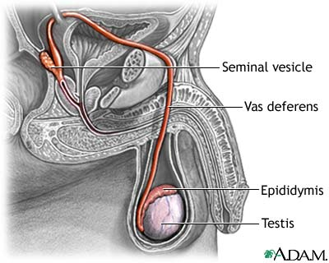
Sperm Route:
1. Sperm leaves the _______________.
2. Then it goes to the ____________________________ (sperm matures here).
Sperm are stored in this tube.
3. Next, it goes to the ___________________________ another tube that
passes from the ____________________ into the body and through the prostate gland.
4. The prostate gland surrounds the neck of the __________________________.
5. As sperm moves through the __________________________, it mixes with fluids from
other _______________________ (including prostate).
6. To leave the body, the semen passes through the vas deferens into the ___________________.
7. urethra-____________________________________________________________________
Female Reproductive System
- This system produces ___________________________________________________________
_____________________________________________________________________________.
Female Reproductive Organs
1. ovaries-__________________________________________________________________________
These also release ____________________________________________ (main female sex hormones).
2. uterus-_____________________________________________________________________________
3. vagina-_____________________________________________________________________________

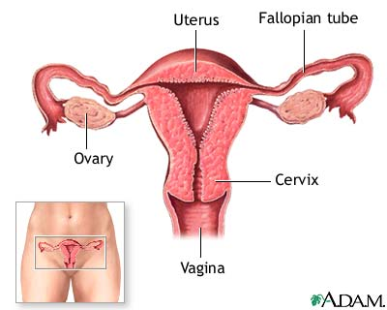

The Egg’s Journey
- __________________________________-an egg is released from an ovary and passes into a fallopian tube.
- The _____________________________________ goes from each ovary to the uterus.
- The egg passes through the fallopian tube through the ___________________________.
- Fertilization usually occurs in the____________________________________________.
- If the egg is fertilized, the ______________________ enters the uterus.

A Baby is Born
- A baby, then passes from the uterus through the _____________________ to the outside of the body.

- menstrual cycle-____________________________________________________________________
  - It is a monthly discharge of ___________________ from the ____________. It lasts about
________ days.
  - Ovulation occurs about the ________ day of the cycle.
  - If egg is not fertilized within a few days, the egg is _______________ away when menstruation begins.
  - The menstration cycle usually takes about _______ days.
Multiple Births
- _____________________ are the most common multiple births.
- Births of ____________________________ (5) or more happen once in 53,000 births.
- ______________________________________- come from the splitting of only one fertilized egg. They will have the same identical _______ (genes), so they will look alike.
- About ________ of all twin births are identical.
- ___________________________ come from the fertilization of two different eggs. It can occur in the lab, as with in vitro fertilization, or spontaneously during a double ovulation (1 in 80-90 pregnancies).
- Fraternal twins are _____________ common than Identical Twins.
- ________________________ twins will look similar, but like siblings.
- For every 1,000 births, ______ sets of twins.
Reproductive System Problems
- STD-___________________________________________________-____________________________
_________________________________________________________________________________
- Types of STD:___________________________________________________________________

  - Aquired Immune Deficiency (AIDS)-___________________________________________
_______________________________________________________________________

Cancer
- _________________ is a disease in which cells grow at an uncontrolled rate.
- Cancer cells can lose the molecules on their ________________ that keep normal cells in the right place. So they can become detached from their neighboring cells. This partly explains how cancer cells spread to other parts of the body.
- Two most common cancers for men: ___________________________________________________
- Two most common cancers for women: _________________________________________________
Infertility
- About ________ of married couples have difficulty producing a child.
- Many are ____________________ (unable to have a child).
- Why does this happen? A woman may not _______________________ normally or a man
may not produce enough ______________________ sperm.
- _______________________________ can lead to infertility in women.

