Chapter 4 Plate Tectonics Section 3: The Theory of Plate Tectonics

___________________________-the theory that the Earth’s lithosphere is divided into tectonic plates that move around on top of the asthenosphere
___________________________________________-a place where tectonic plates touch
Tectonic Plate Boundaries:
- _________________________________ Boundaries: When two tectonic plates collide, the boundary between them is a convergent boundary.
- ______________________________ Boundaries: When two tectonic plates separate, the boundary between them is called a divergent boundary.
- _______________________________ Boundaries: When two tectonic plates slide past each other horizontally, the boundary between them is a transform boundary.
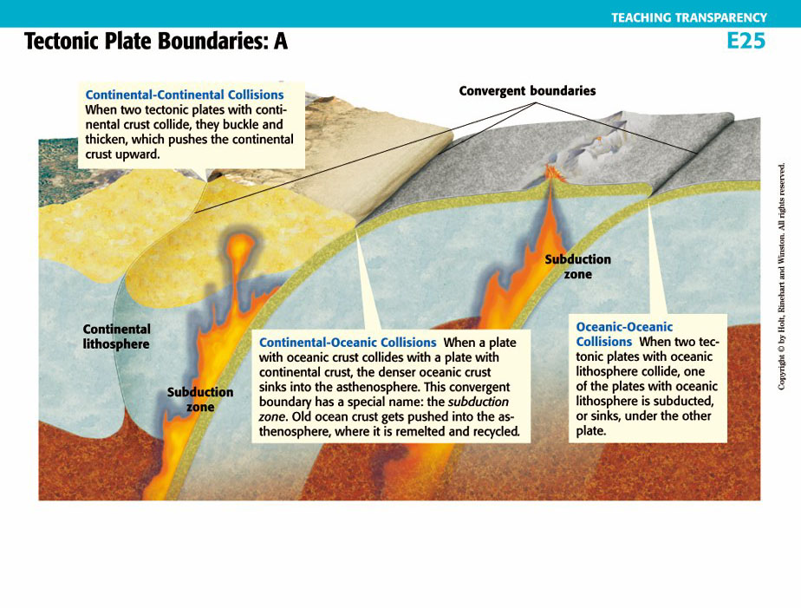
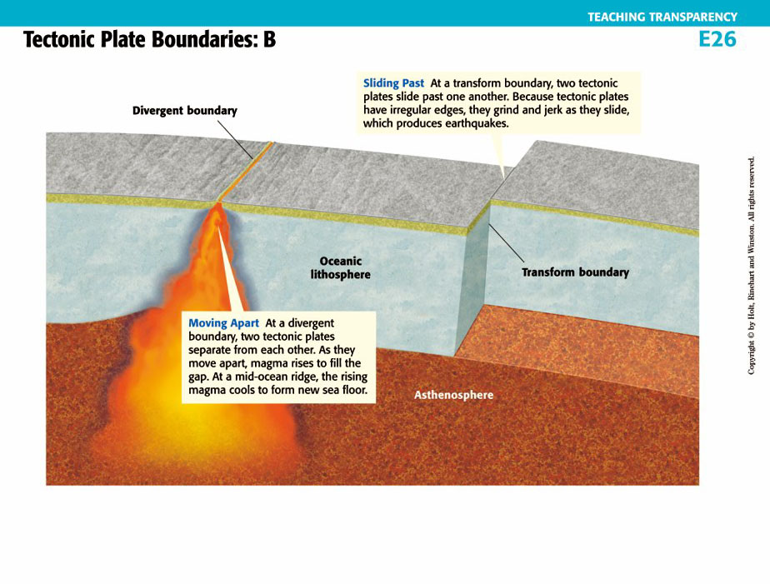

Possible Causes of Tectonic Plate Motion
- __________________________________________________: The solid rock of the asthenosphere flows very slowly. This movement occurs because of changes in density within the asthenosphere. These density changes are caused by the outward flow of thermal energy from deep within the Earth. The movements of the asthenosphere may lead to tectonic plate motion.
- There are three possible causes:
Ridge Push, Slab Pull, and Convection (the lava lamp theory)

Tracking Tectonic Plate Motion
- Measuring ___________________________________________-Tectonic plate movements are so slow and gradual that you can’t see or feel them— the movement is measured in centimeters per year.
- _____________________________________________________-Scientists use this system of satellites , abbreviated (GPS), to measure the rate of tectonic plate movement.

