Chapter 2: Rocks: Mineral Mixtures Section 1
The Rock Cycle
____________-a naturally occurring solid mixture of one or more mineral
_______________________-the continual process by which new rock forms from old rock material
erosion-____________________________________________________________________________
What is the cause? ________________________________________________________________ can erode and move sediments
__________________________________-the process where sediment is moved by erosion is dropped and comes to rest
Where is the sediment deposited? ________________________________________________________
_____________________________________________________________________________________
What happens when temperature and pressure are high at the bottom of the sediment?
1._________________________________________________________________________________
___________________________________________________________________________________

2.__________________________________________________________________________________
___________________________________________________________________________________

uplift-______________________________________________________________________________
____________________________________________________________________________________

________________________________-the process where water, wind, ice, and heat break down rock
Why is this important? ________________________________________________________________
____________________________________________________________________________________

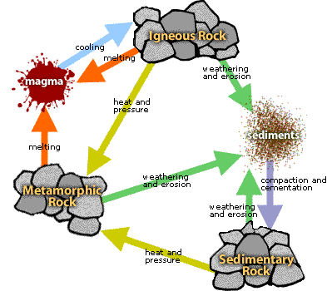Rock Cycle

The Rock Cycle is a group of changes in which:
- ________________________________ can change into metamorphic rock or into igneous rock.
- __________________________________ can change into igneous or sedimentary rock.
- _____________________ can change into sedimentary rock or into metamorphic rock
1. Sedimentary Rock
- Sedimentary rocks form ___________________ the earth's surface. Grains of sand and sediment are eroded from hills and mountains and washed down a ____________________
____________________________________________________.
- Sediments form thick layers on the ___________________________________.
- Grains of sediment are compacted and cemented together to form a _____________________________________________.

2. Metamorphic Rock
- Metamorphic Rock is formed when rocky material experiences ________________________
__________________________________ in the crust of the earth.
- _________________________ rocks and ____________________________ rocks can change into metamorphic rocks, and a metamorphic rock can change into another type of metamorphic rock.
- ____________________________________ do not change the chemical makeup of the parent rocks but they do change the mineral structure and physical properties of those rocks.

3. Magma
- _____________________________________________________________________________
_____________________________________________________________________________

4. Igneous Rock
- Igneous rock is formed when __________________ cools and makes crystals.
- Igneous rock can form ___________________________where the magma cools slowly or it can form _________________ ground where the magma cools quickly.
- Magma is usually ___________________________ than the other rock so it tends to rise up where is cools and becomes an igneous rock.
5. Sediment
- Igneous rocks become exposed at the ________________ of the Earth due to uplift and erosion.
- The igneous rock then ___________________________________________ into gains of sand and clay. These grains of sediment are _________________________ and _______________________________.
- Then, the ________________ starts again.

- The ___________________________of the rock determines which natural forces will have the biggest impact on the process of change.
- For example, rock at the Earth’s surface is affected most by ___________________________
_______________________________________ , whereas, deep inside the Earth, rocks change because of extreme ________________________________________________.

How do scientists know how to classify rocks?
- They study rocks in detail using: 1. _____________________________________
2. _____________________________________

Composition-_______________________________________________________________________
A rock made of quartz will have a composition similar to ___________________, but a rock made of 50% quartz and 50% feldspar will have a __________________________ composition than quartz does.

__________________________________-the size, shape, and position of the grains that make up a rock
- ____________________________ rock can have a fine-grained, medium-grained, or coarse-grained texture.
- __________________________ rock can be fine-grained or coarse grained
- This depends on how much time the _________________ has to cool.
- _______________________________ rock can be fine-grained or coarse grained too.

